***Izorcrest***

* The mountain is surrounded by an unnatural snowfall that ranges from light snow to blizzards even in the summer (this is a vestige of the ancient white dragon’s powerful magic)
* Izorcrest is the name of the castle, though it also has a village at the base of the mountain simply called Izorholm
* The small evergreen forest that rings the mountain is known as Wolfstone Forest, as it was planted by the ancient hero following his battle with Izorithax
* There is a regional accent in and around the mountain that resembles Austrian/German that comes from the dialect of Izorithax himself and is a vestige of his millennia of rule over the region (also, locals speak a regional dialect of draconic that reflects this accent)
* The castle of Izorcrest can be reached by entering a gate at the base of the mountain and riding a clockwork elevator shaft up the interior of the mountain to the castle which sits upon the snowcapped peak
* There are still glaciers in the cruxes of the mountain that yet thaw, leading to beautiful sparkling waterfalls cascading down parts of the mountain
* The castle itself is made up of white marble veined with silver and lapis lazuli, mined from the mountain itself
* There are several spots of interest in Izorcrest:
  + The Ducal Halls
    - The Ducal Gallery (Includes Duke’s Throne & Feasting Hall)
    - Solar of the Duke (Duke’s Bedchambers & Office)
    - The Dragonvault (Contains the family’s wealth and the hoard of Izorithax, looted by Gorim)
    - Hina’s Archive (Library tower that houses the collected works first begun by Gorim’s granddaughter, Hina, containing information on fighting dragons, Drakebeard’s family histories, etc.)
    - (Various other noble bedchambers)
  + The Drakebeard Catacombs
  + Upper Courtyard
    - Shrine to Moradin
  + The Domestic Halls (Lower halls and towers, housing servants and guards and contains kitchens, barracks, armory, etc.)
  + Lower Courtyard
    - Blacksmith
* There are several spots of interest in Izorholm:
  + The Bearded Lady (Inn & Tavern)
  + Shrine to Moradin
  + Fletcher
  + Old Marble Quarry
  + Hunter’s Lodge (On outskirts of village and forest)
  + Wolfstone Forest (Deer, squirrels, & mysterious moss-covered statues of wolves throughout)

**Izorcrest Castle**

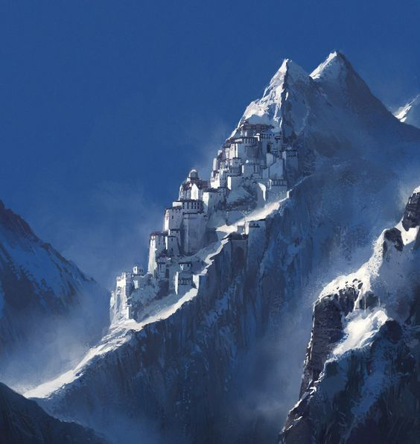

**The Gates**

